**Create VPC:** Lab-Clowdwatch-VPC / CIDR 10.0.0.0/24

**CreateSubnet:** Lab-CloudWatch-Subnet / CIDR 10.0.0.0/26 under the new VPC

**Create Internet Gateway that will be attached to the VPC:**

Lab-VPC-Flow-Log-IG

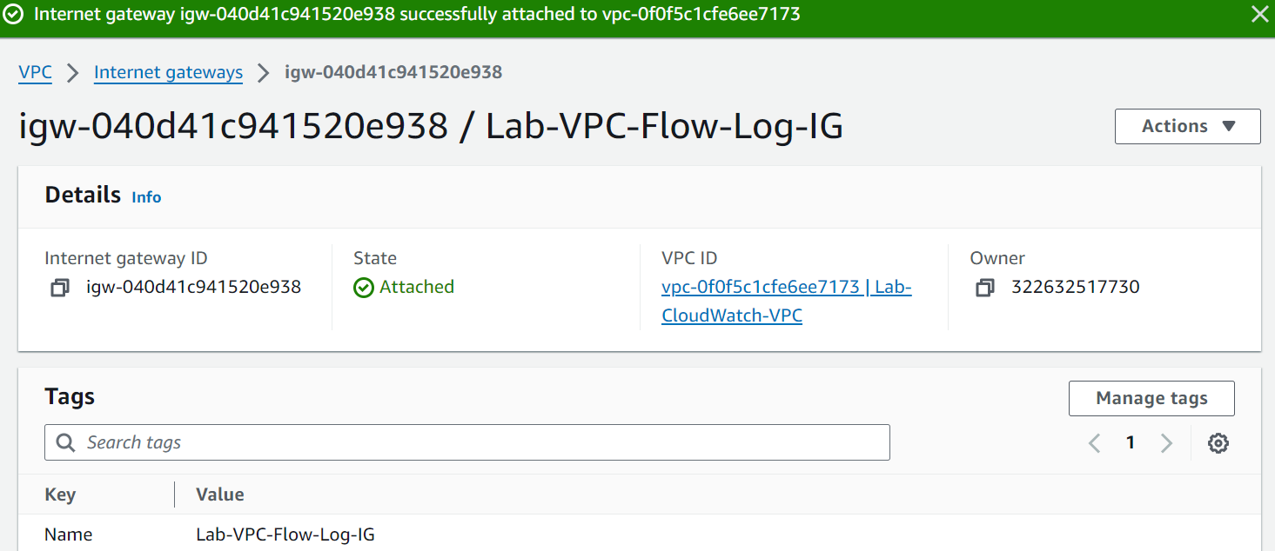

**Update a new Route Table to reference the New IG**

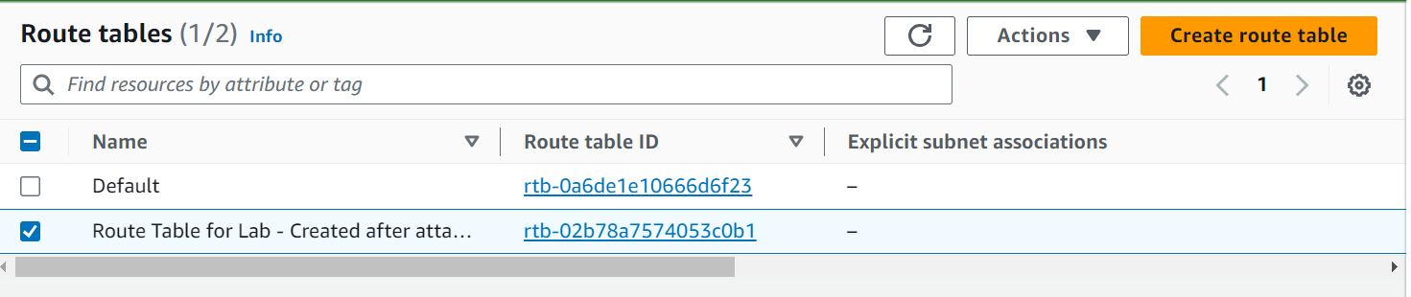

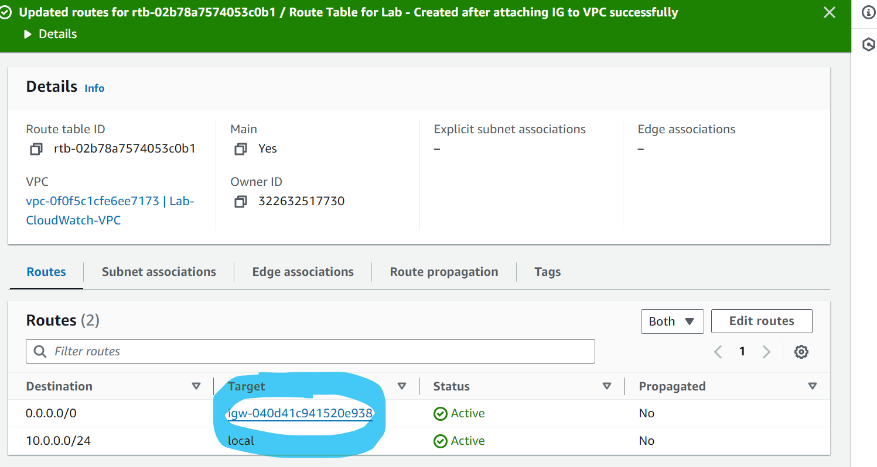

**Create EC2 Security Group:**

**Security group name**: Lab-CloudWatch-SSH

**Description**: Lab-CloudWatch-SSH

For **VPC**, select **Lab-CloudWatch**

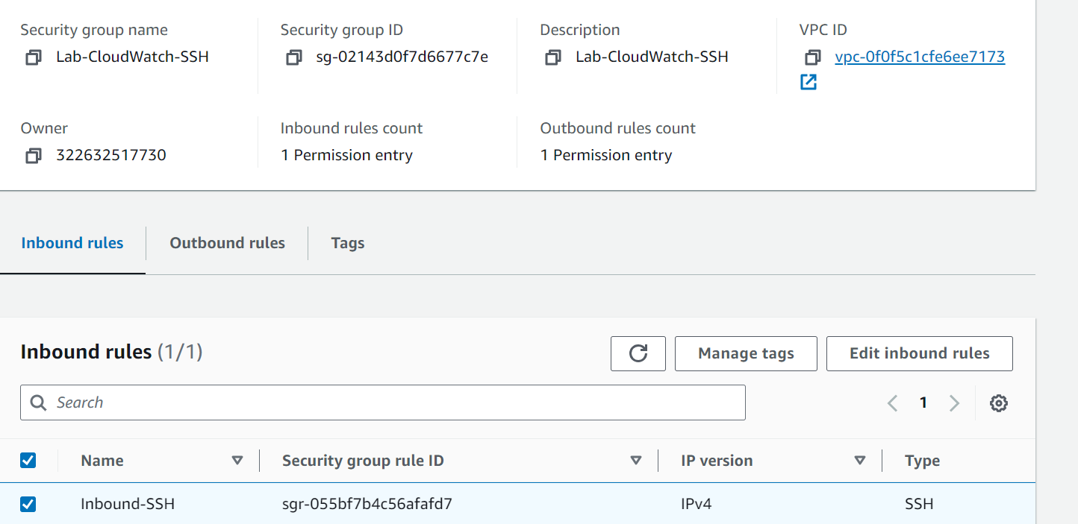

**EC2: Under new VPC/Subnet/SG**

|  |  |
| --- | --- |
| Lab-Cloudwatch-EC2 | [i-0a08b7b96b3ca7eed](https://us-east-1.console.aws.amazon.com/ec2/home?region=us-east-1#InstanceDetails:instanceId=i-0a08b7b96b3ca7eed) |

**Cloudwatch Dashboard:**

**Lab-CloudWatch-Dashboard and Wadgets are created.**

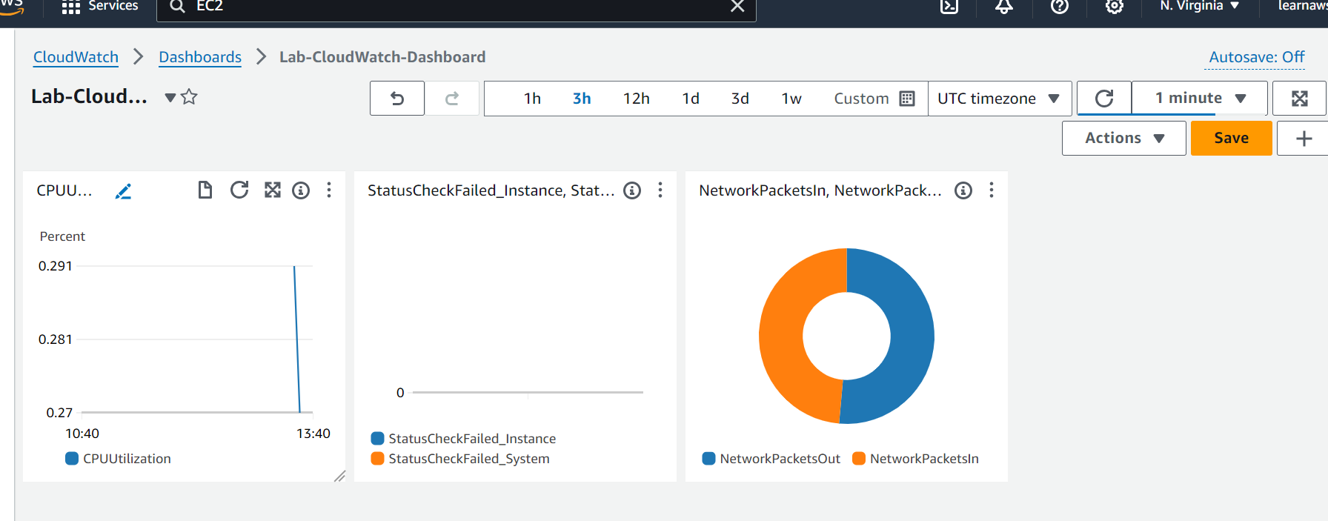

**Cloudwatch alaram**

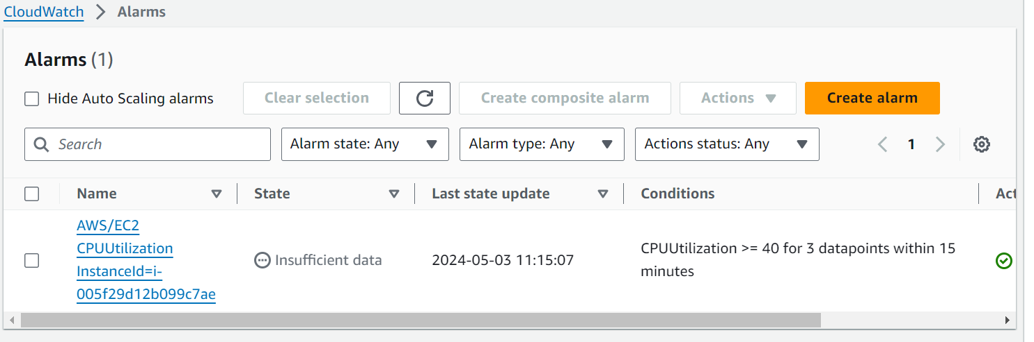

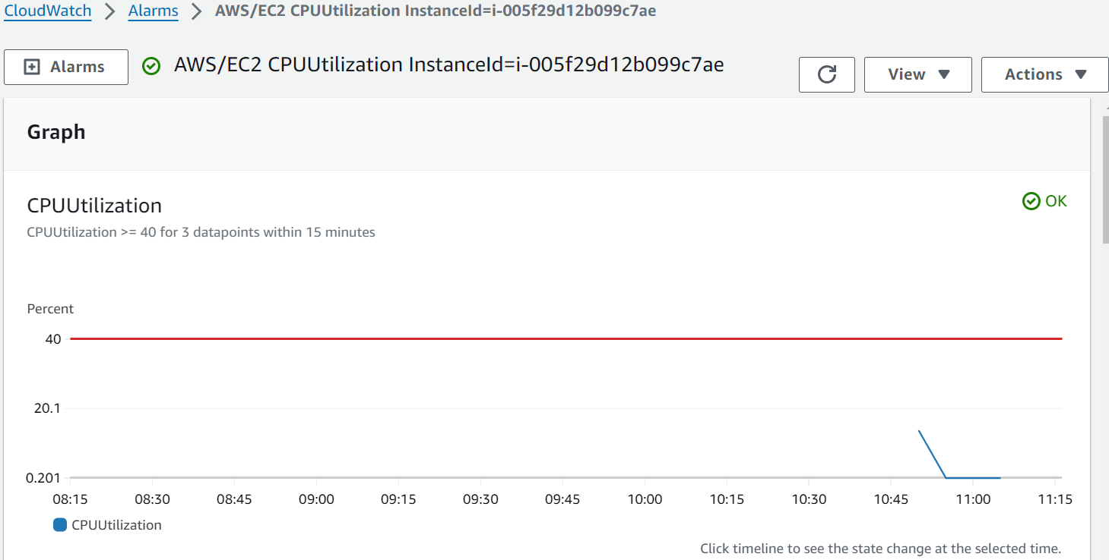

**Stress utility**

**sudo amazon-linux-extras install epel -y**

**sudo amazon-linux-extras install epel -y**

sudo yum install stress -y

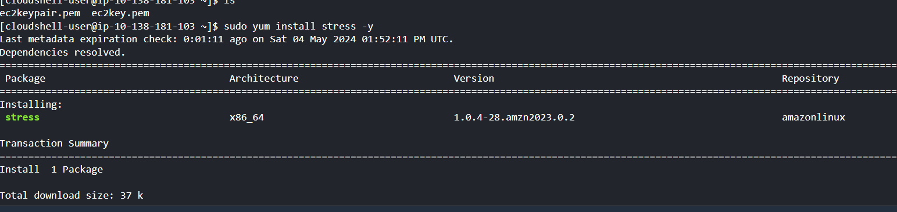

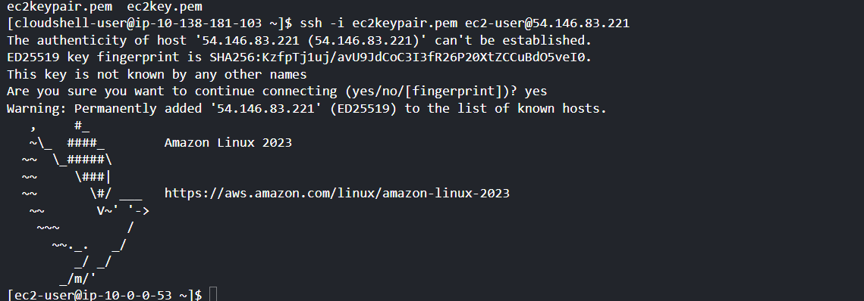

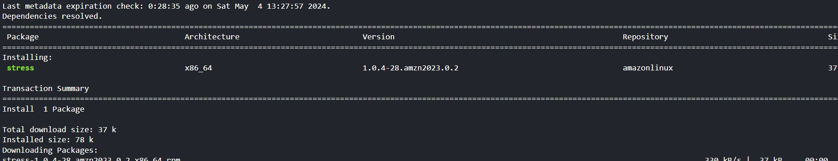

sudo stress --cpu 8 --timeout 800 &

**ssh -i ec2keypair.pem** [**ec2-user@54.146.83.221**](mailto:ec2-user@54.146.83.221)

